Approval and Authorization

 | WRITTEN BY | REVIEWED BY
Signature:
Position:
Date:

 | APPROVED BY | AUTHORIZED BY
Signature:
Position:
Date:

- INTRODUCTION TO QUALITY MANUAL
  - Overview of organization
BIOMEDICAL LIMITED is a fast-growing pharmaceutical manufacturing company specializing in the production of intravenous solutions in flexible PP bags under Bioflex brand and in Oral Liquid products.
Incorporated in 1978, the company commenced commercial production on 21st August 1981. This pioneer industry has remained the foremost producer of IV fluids in Nigeria as our products extensively used in many hospitals.
Biomedical Limited has developed a strong identity in the field of kidney therapy. We pioneered the local production of both the peritoneal dialysis fluid, and the hemodialysis concentrates in 1985. The company has evolved dynamically to meet customers’ demand, specializing in both the production of intravenous and oral liquids products.
  - Mission Statement
To create the right ambience by enabling careers, promoting equity and fairness, and encouraging aspirations to facilitate production of world class pharmaceuticals.
  - Vision Statement
To be the quality reference in pharmaceuticals industries.
  - Quality Statement and Management Commitment
At Biomedical Limited, Management Team through our practices, standards, and consistent commitment to quality demonstrates “leadership by example”. They provide complete commitment and allocate resources to implement and maintain the quality policies and programs aimed at continually improving the Quality Management System (QMS).
The management team is charged with establishing clarity of direction and unity of purpose across the organization, fostering an environment in which the organization and its people can perform effectively and contribute to organizational excellence. All employees of the company are not only required to comply and internalize quality principles but contribute to the provisions of the quality management, integrating them into their daily activities. Continuous quality improvement is a shared responsibility, and employees at all levels are empowered to identify opportunities for improvement.
Biomedical Limited is committed to becoming a benchmark for quality excellence within the pharmaceutical industry. As such, managers are accountable for ensuring that their teams are so instructed, and fully understand applicable requirements, and consistently adhere to established policies, procedures, statutory obligations and regulatory standards, and thereby complying with these objectives.
- Our aim is to be quality reference in the pharmaceutical Industry
- We ensure that we can deliver the defined quality goals and targets by the establishment and implementation of management objectives and processes, which are monitored against the requirements of our customers’ needs and expectations, our internal business management system, ISO9001:2008 and all applicable statutory and regulatory requirements. Progress against set goals and measurable targets is monitored and evaluated through a management review process.
- We delight our customers and develop relationships with all suppliers both internal and external, working in partnership, developing mutually beneficial relationships built on trust, sharing of knowledge and integration. It is our aim to meet all supply chain requirements and to provide significant and measurable successes.
WHAT MAKES US UNIQUE
- Our commitment to total quality
- Our determination and vision
- Our timely delivery of affordable, yet quality pharmaceutical products
- Our discipline workforce
- Our compatibility
- Our professionalism
- Our finance strength and ability
- International experience and expertise
- Zero tolerance for defects.
Ultimate responsibility for the achievement of these objectives rests with the Managing Director supported by the Management Team with the responsibility and authority to implement company policies.

Muthukumarraja Chidambaram
MD

  - Scope
This quality manual describes the quality management system of Biomedical Limited. Its scope covers the quality system established and maintained for the manufacture and commercial supply of her pharmaceutical products.
The manual defines the framework under which Biomedical Limited controls activities related to manufacture, storage and distribution of drug products. It references supporting documentation including standard operating procedures, quality plans, specifications, validation protocols, work instructions, and other controlled documents that are part of the Quality Management System.
This manual serves the following purposes:
Internal use –
- To communicate Biomedical Limited’s Quality Policy and Quality Objectives to all employees.
- To ensure personnel understand the processes and controls implemented to achieve and maintain compliance with Quality Management System requirements and applicable regulatory standards, including Good Manufacturing Practice (GMP).
- To provide a structured framework for the effective implementation, maintenance, and continual improvement of the Quality Management System.
- To support consistency in manufacturing operations, storage practices, and distribution controls.
- To serve as a reference document during internal audits, management reviews, and regulatory inspections.
External use –
- To inform regulatory authorities, customers, and other external stakeholders of Biomedical Limited’s Quality Policy and established Quality Management System.
- To demonstrate the company’s ability to consistently manufacture and supply pharmaceutical products that meet customer expectations and regulatory requirements.
- To provide documented evidence of compliance with applicable regulatory standards, including current Good Manufacturing Practice (cGMP).

The intent of this Quality Manual and its associated procedures is to demonstrate Biomedical Limited’s capability to consistently provide products that meet defined quality standards and regulatory obligations, while enhancing customer satisfaction through the effective application and continual improvement of its Quality Management System processes.
- QUALITY POLICY
Quality is the foundation of Biomedical Limited’s culture. Biomedical Limited is committed to the consistent manufacture, supply, and marketing of safe, effective, and high-quality pharmaceutical products, including world-class Large Volume Parenterals and Oral Liquids, in full compliance with current Good Manufacturing Practice, applicable regulatory requirements, and global best practices.
Top Management ensures that this Quality Policy is documented, communicated, understood, implemented at all levels of the organization, and periodically reviewed for continued suitability and effectiveness. The company operates an effective Pharmaceutical Quality System focused on product quality, patient safety, regulatory compliance, customer satisfaction, and continual improvement.
This commitment is supported by competent, highly skilled, and well-motivated personnel, adequate resources, and a culture of continual development, innovation, and improvement of the Quality Management System to consistently meet customer expectations, regulatory requirements, and the evolving needs and aspirations of our stakeholders.

Policy Ratification
S/No | Name | Position | Signature
1 | Mrs. Toyin Utomakili | Deputy Managing Director
2 | Mr. AbdulRauf Tiamiyu | Executive Director, Finance and Corporate Services
3 | Mr. Liadi A. Agboola | Factory Manager
4 | Mrs. Abigael Koroma | Quality Manager
5 | Mr. Ibrahim Adedapo | Engineering Manager
6 | Mr. Sola Otitolaye | HR/Admin. Manager
7 | Mr. Michael Oyewusi | Marketing Manager
8 | Mr. Innocent Agwunobi | Audit Manager
9 | Mr. Femi Adeyanju | Sales Manager

- QSE: ORGANIZATION
3.1 Organization policy
The management has the authority, competence and responsibility for the products manufactured and services rendered.
The management shall ensure the following:
- There are no activities that compromise the quality of its products and safety of its employees and environment, and shall provide administration at areas with high risk.
- There are appropriate procedures to ensure that ethical protection of customers and environment.
- Duties and responsibilities of personnel are defined.
- Safety officer are designated.
- Quality champion is designated.
3.2 Organization chart
The internal organization consists of a team of professionals in themes listed below.
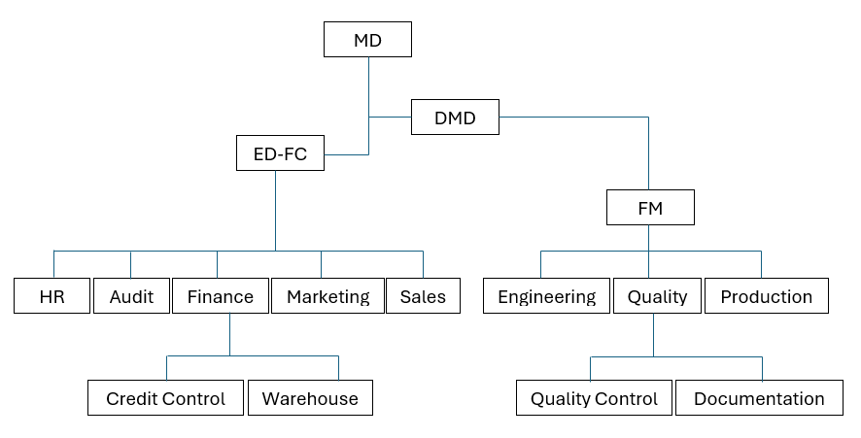
3.3 Conflict of interest
Biomedical Limited is committed to preventing, identifying, and managing conflicts of interest. All decisions shall be made based on quality, safety, compliance, and business integrity, without undue influence from personal or external interests. No individual shall place themselves in a position where personal interests conflict with their professional responsibilities.
Biomedical Limited is not committed to any commercial, financial or other pressure provided by any organization that could influence its technical and executive judgement or affect its competencies and trust.
All employees and relevant third parties are charged with declaring any actual, potential or perceived interest upon employment, appointment or engagement, or disclose conflict of interest as soon as it arises. Failure to disclose a conflict of interest may result in disciplinary action.
3.4 Internal Communication
In addition to the Management Review meetings held biannualy and governed by SOP – BML-QDG-QA-080, there shall be weekly HOD meeting and a monthly technical meeting involving Directors and their managers. During the meetings:
- Activities of the week are reviewed and activities to be performed are defined.
- All information on general organisation, actions and projects is communicated.
Minutes (notes) are taken of meeting discussions, and a report communicated to all directors and managers.
The management ensures appropriate downstream communication takes place to keep staff informed using excerpts of the meetings.
3.5 Personnel Responsibilities

3.6 Supporting Documents
- QSE: FACILITIES AND SAFETY
- QSE: EQUIPMENT
- QSE: PURCHASING AND INVENTORY
- QSE: PROCESS MANAGEMENT
- QSE: ASSESSMENT
- QSE: PERSONNEL
- QSE: CUSTOMER FOCUS
- QSE: NON-CONFORMING EVENT MANAGEMENT
- QSE: DOCUMENTS AND RECORDS
- QSE: INFORMATION MANAGEMENT
- APPENDICES

